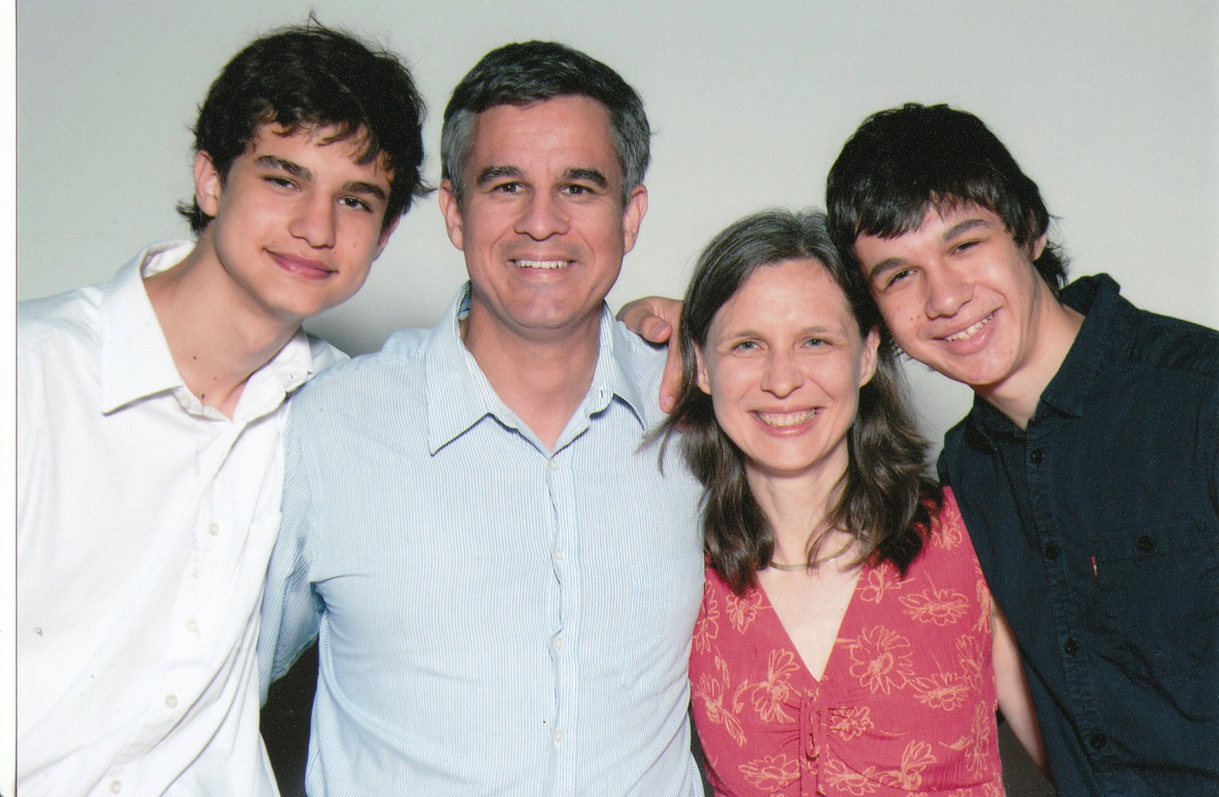 | 1. The establishment of at least 20 new Discovering God Together groups each year.  2. At least 20 new health builders to be trained each year.  3. At least 20 new poultry-producing health builders to begin successfully incubating eggs.  4. At least $7000 to be raised over the next 3 years to equip 60 health builders with tablets for health promotion and skill development.  5. The Holy Spirit to provide health and strength so that Rick and Anita can accomplish these goals. | Prayer Requests

Pictured above (left to right): Paul, rick, anita, and marc

Drs. Rick and Anita Gutierrez serve in Durban, South Africa, together with International Ministries partner: the Baptist Mission of South Africa. They train and equip local churches, pastors and missionaries to combat life-style related diseases like HIV/AIDS, heart and artery disease, diabetes and malaria. Portable rapid screening tests for these conditions are offered by trained health builders. The doctors continue to develop a health education DVD series that can be studied individually or in small groups. A holistic approach from the Christian perspective is offered in order to help people achieve their health and life goals.
The vision is to train two or four health builders in each participating church. They would like to see this model of health building become a part of local church missions throughout Africa and other resource-limited settings.

Rick March 19
Anita June 24
Marc June 29
Paul December 11

rick.gutierrez@internationalministries.org
anita.gutierrez@internaionalministries.org

To learn more about Rick and Anita, visit www.internationalministries.org. There you can access their most recent newsletters, read more about their projects, and discover more opportunities to get involved with their ministry.

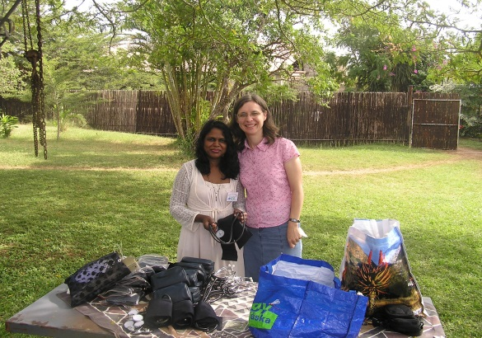

Rick and Anita Gutierrez
Training Health Builders
Pictured above is Anita with a Zulu woman that she has trained to become a health builder. Together they meet medical needs, as well as lead community Bible studies.
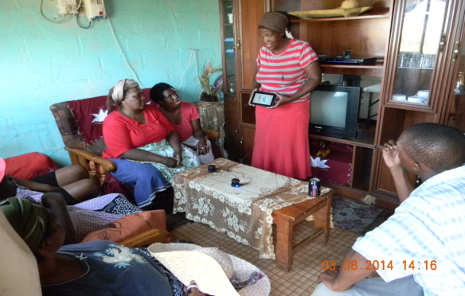

Birthdays:

Contact Info:
Tablets for Health in South Africa
Building on previous successes, this project seeks to raise $7,000 per year in the next 3 years to equip 60 health builder trainers in South Africa with tablets for health promotion and skill development.

