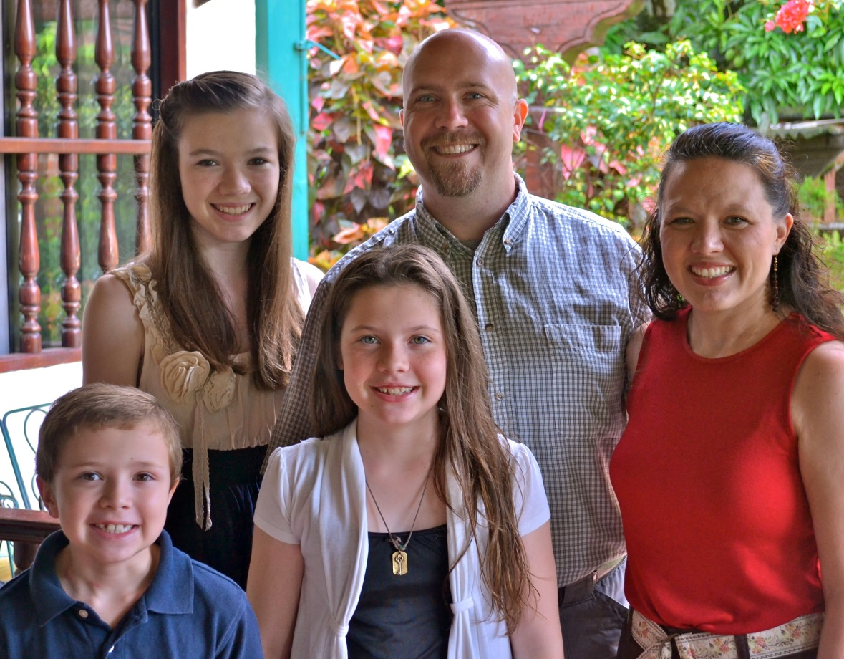 | 1. The School of Leaders project as it grows to become a regional program, expanding to new cities.  2. That God would continue to provide leaders and help them develop innovative ministry opportunities that will rise to the challenges of a growing urban population in Bolivia.  3. Rhonda as she works in the school and explores other health-related ministry opportunities.  4. The ministries of the Bolivian Baptist Union as they continually emerge in Southern Bolivia. | Prayer Requests

Pictured above (left to right): Nathanael, Grace, ABie, J.D., and Rhonda

J.D. and Rhonda are currently serving in partnership with the Union Bautista Boliviana and live in the city of Santa Cruz de la Sierra. Their primary focus is aiding in the development of leadership in the areas of theology, mentoring pastors and helping to develop new ministry opportunities in the southern part of Bolivia. Rhonda is also volunteering as a school nurse at their children’s mission school and assisting with short-term volunteer medical teams.
The training they do is through an International Ministries project “School of Leaders”, where more than 50 local pastors and leaders have already enrolled. For many of them, this is the first time they have ever completed a survey of the entire Bible.
This project is currently only located in Santa Cruz, but they are working on expanding it to around the country.

jd.reed@internationalministries.org
rhonda.reed@internationalministries.org

To learn more about J.D. and Rhonda, visit www.internationalministries.org. There you can access their most recent newsletters, read more about their projects, and discover more opportunities to get involved with their ministry.

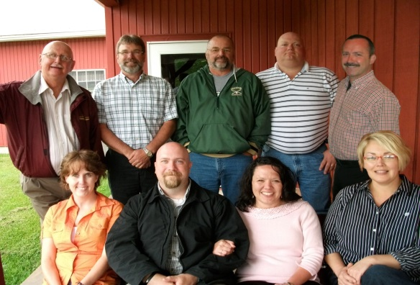

J.D. and Rhonda Reed
Missionary Partnership Team
Pictured above is the Missionary Partnership Team (MPT) for the Reed’s. They are made up of various members from WV Baptist churches.
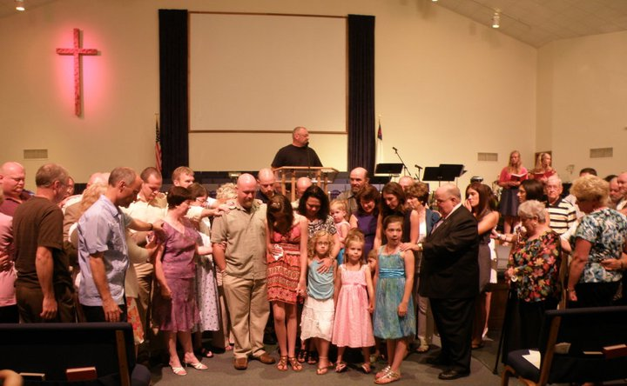
Nathanael March 10
Grace April 7
Abigail May 29
Rhonda September 1
J.D. December 21

Birthdays:

Contact Info:
Commissioning Service
The Reeds were commissioned in July 2011. They were sent out to Bolivia from South Parkersburg Baptist Church, where JD served as one of the pastors. Pictured above are members of their church praying over them as part of the commissioning.

