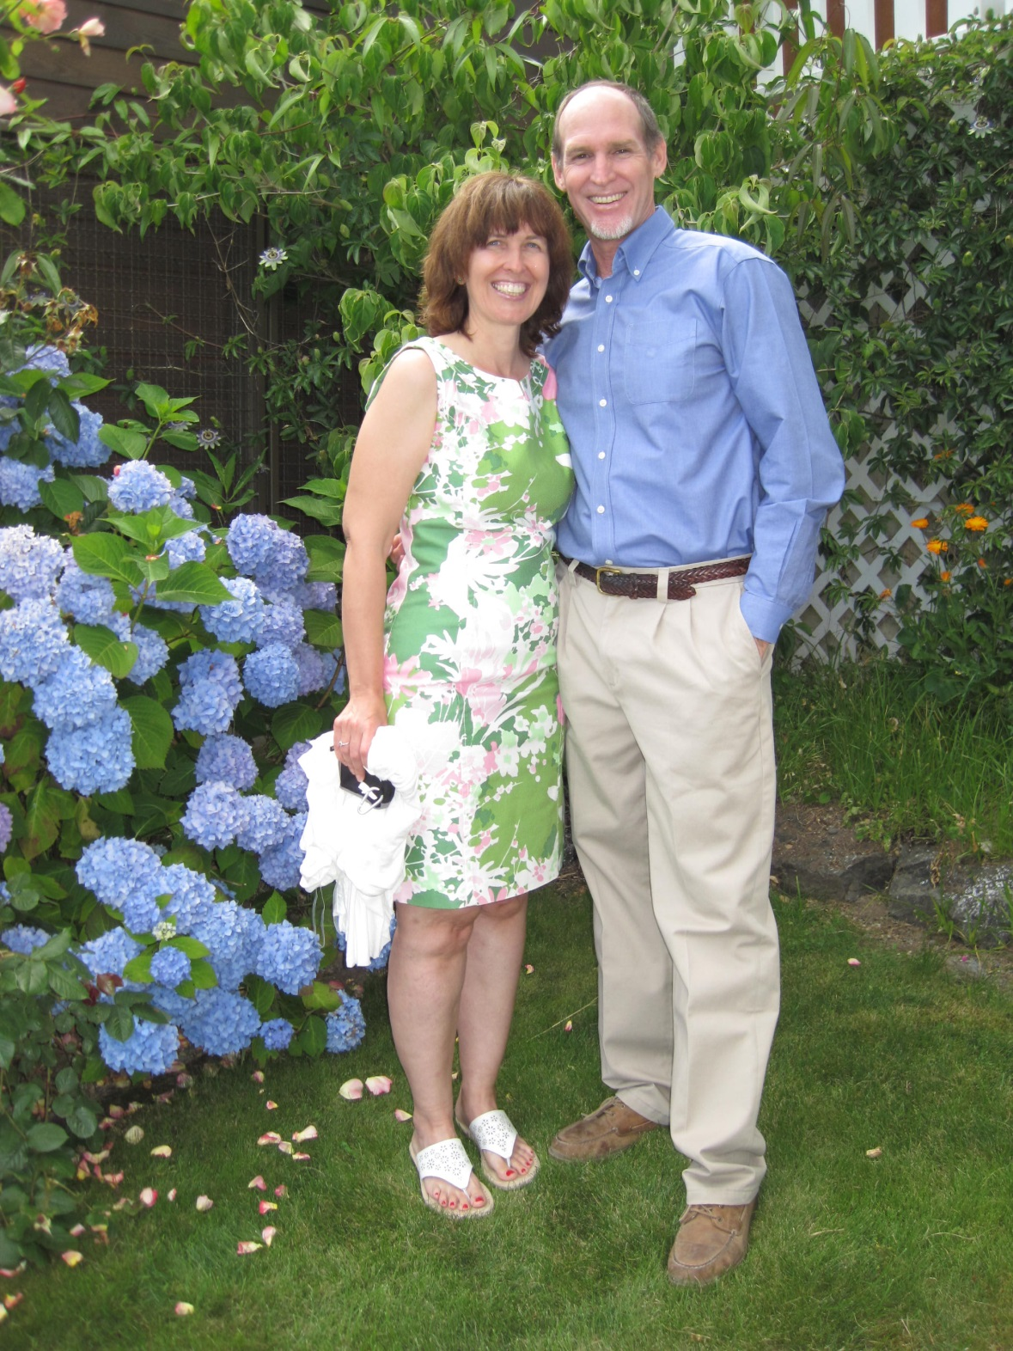 | 1. The full-time students enrolled in their Theological Extension School. All are college-aged and full of energy!  2. The mission teams that are coming to further work on the school’s construction.  3. The Convention to form a long-term strategy to financially sustain its programs.  4. The Reeds’ two sons, Ian and Aaron. Ian now works as an engineer in Los Angeles and Aaron is studying youth ministry at Eastern University in Pennsylvania. | Prayer Requests

Pictured above (left to right): Joyce And David

David and Joyce live in La Paz, Mexico, and serve with the Regional Baptist Convention of Southern Baja California. They work with pastors and church leaders in new church development and train leaders through informal and formal theological education, including the Theological Extension School created jointly by the Convention and Lacey Seminary in Oaxaca. Their church development work includes helping the Convention reach out to English-speaking people in La Paz.
Since 2000, when the Reeds landed in La Paz, they have seen the Mexican Baptist Convention of Southern Baja expand from 6 churches to 14 churches, and an interesting fact is that 98% of the people joining these churches had not previously known Jesus! The Reeds have seen God glorified through the growth and transformation of many lives.

david.reed@internationalministries.org
joyce.reed@internationalministries.org

To learn more about David and Joyce, visit www.internationalministries.org. There you can access their most recent newsletters, read more about their projects, and discover more opportunities to get involved with their ministry.

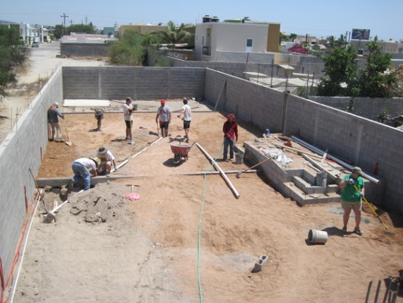

David and Joyce Reed
Constructing the New School
Various mission teams have been working together to help construct the new school. Several teams come from WV Baptist churches.
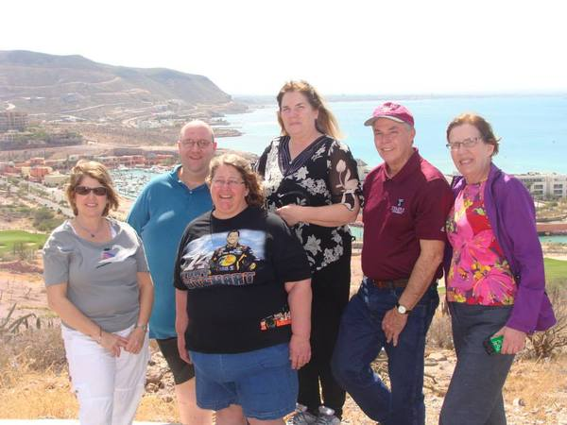
Joyce April 29
David December 25

Birthdays:

Contact Info:
WV Baptist Partnerships
Pictured above is a group from Parkersburg. Several churches around the state help support the Reeds through financial support, prayer, and sending short-term mission trips.

